Consulate General of the Cooperative Republic of Guyana in Toronto, Canada
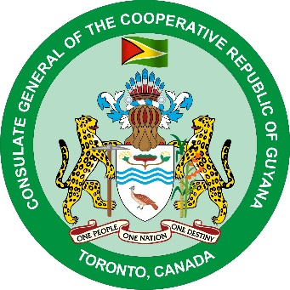
URGENT PUBLIC NOTICE

The Consulate General of the Cooperative Republic of Guyana in Toronto wishes to inform that the National Insurance Scheme(NIS), Guyana in an attempt to facilitate the processing of Pension Life Certificates for pensioners in Canada during the current Covid-19 pandemic has implemented the following procedures:
- All NIS pensioners residing in Canada are required to utilize the Guyana Consulate in Toronto’s video calling services to notarized their NIS Life Certificates. Pensioners who wish to utilized the Consulate’s video calling services can do so by calling telephone numbers 4164946040 or 4164946059 between 9 am -12 pm Monday to Friday or via email address info@guyanaconsulate.com.
- Upon the completion of the video call, the life certificate has to be mailed into the Consulate and upon receipt of the NIS Life Certificate, the Consulate will notarized it and forward a scanned copy via email to the NIS Head Office in Georgetown, Guyana for processing.
- The original notarized Life Certificate will be returned to the pensioner via return mail. The pensioner will be responsible for sending the original signed Life Certificate to the NIS Office, Guyana when the mailing system in Canada resumes service to Guyana.
- Pensioners will be allowed a grace period of one (1) month after the mailing service resumes to send their original Life Certificates to Guyana. Failure to comply with this requirement will result in NIS discontinuing the payment of pension.

Consulate General of the Cooperative Republic of Guyana
Toronto
May 26, 2020

